https://www.studypool.com/documents/3239600/shortcut-formula-for-the-expansion-of-tan-nx-#:~:text=Math%20Technique%20of%20the%20day,Pascal's%20Triangle%20to%20easily%20find

Math Technique of the day for Hanz Baga ^ ^ 𝐄𝐱𝐩𝐚𝐧𝐬𝐢𝐨𝐧 𝐨𝐟 𝐭𝐚𝐧(𝐧𝐱) To express tan(nx) in terms of tan x , we will use the formula given below tan(nx) = n tan x − C(n, 3) tan3 x + C(n, 5) tan5 x − ⋯ 1 − C(n, 2) tan2 x + C(n, 4) tan4 x − ⋯ Alternatively, we can just simply use the modified Pascal’s Triangle to easily find the coefficient of each term in the numerator and denominator of the formula above. 1 1 1 1 2 −1 1 3 −3 −1 1 4 − 6 −4 1 … As you can see, every two entries in each row of the modified Pascal’s Trian ...

<https://oeis.org/A034867>

|  |  |  |  |  |  |
| --- | --- | --- | --- | --- | --- |
| |  |  |  |  |  | | --- | --- | --- | --- | --- | | A034867 |  | Triangle of odd-numbered terms in rows of Pascal's triangle. |  |  | |
| |  |  | | --- | --- | |  | 1, 2, 3, 1, 4, 4, 5, 10, 1, 6, 20, 6, 7, 35, 21, 1, 8, 56, 56, 8, 9, 84, 126, 36, 1, 10, 120, 252, 120, 10, 11, 165, 462, 330, 55, 1, 12, 220, 792, 792, 220, 12, 13, 286, 1287, 1716, 715, 78, 1, 14, 364, 2002, 3432, 2002, 364, 14, 15, 455, 3003, 6435, 5005, 1365, 105, 1 | |

Let T = tan x, then

tan x = T

tan 2x = 2T / (1 - T^2)

tan 3x = (3T - T^3) / (1 - 3T^2)

tan 4x = (4T - 4T^3) / (1 - 6T^2 + T^4)

tan 5x = (5T - 10T^3 + T^5) / (1 - 10T^2 + 5T^4)

tan 6x = (6T - 20T^3 + 6T^5) / (1 - 15T^2 + 15T^4 - T^6)

tan 7x = (7T - 35T^3 + 21T^5 - T^7) / (1 - 21T^2 + 35T^4 - 7T^6)

tan 8x = (8T - 56T^3 + 56T^5 - 8T^7) / (1 - 28T^2 + 70T^4 - 28T^6 + T^8)

tan 9x = (9T - 84T^3 + 126T^5 - 36T^7 + T^9) / (1 - 36 T^2 + 126T^4 - 84T^6 + 9T^8)

... To get the next one in the series, (tan 10x), for the numerator add:

9....84....126....36....1 previous numerator +

1....36....126....84....9 previous denominator =

10..120....252...120...10 = new numerator

For the denominator add:

......9.....84...126...36...1 = previous numerator +

1....36....126....84....9.... = previous denominator =

1....45....210...210...45...1 = new denominator

...where numerators = [A034867](https://oeis.org/A034867), denominators = [A034839](https://oeis.org/A034839)

|  |  |
| --- | --- |
| |  | | --- | | 1, 2, 3, 1, 4, 4, 5, 10, 1, 6, 20, 6, 7, 35, 21, 1, 8, 56, 56, 8, 9, 84, 126, 36, 1, 10, 120, 252, 120, 10, 11, 165, 462, 330, 55, 1, 12, 220, 792, 792, 220, 12, 13, 286, 1287, 1716, 715, 78, 1, 14, 364, 2002, 3432, 2002, 364, 14, 15, 455, 3003, 6435, 5005, 1365, 105, 1 ([list](https://oeis.org/A034867/list); [graph](https://oeis.org/A034867/graph); [refs](https://oeis.org/search?q=A034867+-id:A034867); [listen](https://oeis.org/A034867/listen); [history](https://oeis.org/history?seq=A034867); [text](https://oeis.org/search?q=id:A034867&fmt=text); [internal format](https://oeis.org/A034867/internal)) | |
| |  |  |  | | --- | --- | --- | |  | OFFSET | 0,2 | |  | COMMENTS | Also triangle of numbers of n-sequences of 0,1 with k subsequences of consecutive 01 because this number is C(n+1,2*k+1). - Roger Cuculiere (cuculier(AT)imaginet.fr), Nov 16 2002  From [Gary W. Adamson](https://oeis.org/wiki/User:Gary_W._Adamson), Oct 17 2008: (Start)  Received from [Herb Conn](https://oeis.org/wiki/User:Herb_Conn):  Let T = tan x, then  tan x = T  tan 2x = 2T / (1 - T^2)  tan 3x = (3T - T^3) / (1 - 3T^2)  tan 4x = (4T - 4T^3) / (1 - 6T^2 + T^4)  tan 5x = (5T - 10T^3 + T^5) / (1 - 10T^2 + 5T^4)  tan 6x = (6T - 20T^3 + 6T^5) / (1 - 15T^2 + 15T^4 - T^6)  tan 7x = (7T - 35T^3 + 21T^5 - T^7) / (1 - 21T^2 + 35T^4 - 7T^6)  tan 8x = (8T - 56T^3 + 56T^5 - 8T^7) / (1 - 28T^2 + 70T^4 - 28T^6 + T^8)  tan 9x = (9T - 84T^3 + 126T^5 - 36T^7 + T^9) / (1 - 36 T^2 + 126T^4 - 84T^6 + 9T^8)  ... To get the next one in the series, (tan 10x), for the numerator add:  9....84....126....36....1 previous numerator +  1....36....126....84....9 previous denominator =  10..120....252...120...10 = new numerator  For the denominator add:  ......9.....84...126...36...1 = previous numerator +  1....36....126....84....9.... = previous denominator =  1....45....210...210...45...1 = new denominator  ...where numerators = [A034867](https://oeis.org/A034867), denominators = [A034839](https://oeis.org/A034839) | |
|  |
| |  |  |  |  |  | | --- | --- | --- | --- | --- | | A034839 |  | Triangular array formed by taking every other term of each row of Pascal's triangle. |  | 37 | |
| |  |  | | --- | --- | |  | 1, 1, 1, 1, 1, 3, 1, 6, 1, 1, 10, 5, 1, 15, 15, 1, 1, 21, 35, 7, 1, 28, 70, 28, 1, 1, 36, 126, 84, 9, 1, 45, 210, 210, 45, 1, 1, 55, 330, 462, 165, 11, 1, 66, 495, 924, 495, 66, 1, 1, 78, 715, 1716, 1287, 286, 13 ([list](https://oeis.org/A034839/list); [graph](https://oeis.org/A034839/graph); [refs](https://oeis.org/search?q=A034839+-id:A034839); [listen](https://oeis.org/A034839/listen); [history](https://oeis.org/history?seq=A034839); [text](https://oeis.org/search?q=id:A034839&fmt=text); [internal format](https://oeis.org/A034839/internal)) | |
| |  |  |  | | --- | --- | --- | |  | OFFSET | 0,6 | |  | COMMENTS | Number of compositions of n having k parts greater than 1. Example: T(5,2)=5 because we have 3+2, 2+3, 2+2+1, 2+1+2 and 1+2+2. Number of binary words of length n-1 having k runs of consecutive 1's. Example: T(5,2)=5 because we have 1010, 1001, 0101, 1101 and 1011. - [Emeric Deutsch](https://oeis.org/wiki/User:Emeric_Deutsch), Mar 30 2005  From [Gary W. Adamson](https://oeis.org/wiki/User:Gary_W._Adamson), Oct 17 2008: (Start)  Received from [Herb Conn](https://oeis.org/wiki/User:Herb_Conn):  Let T = tan x, then  tan x = T  tan 2x = 2T / (1 - T^2)  tan 3x = (3T - T^3) / (1 - 3T^2)  tan 4x = (4T - 4T^3) / (1 - 6T^2 + T^4)  tan 5x = (5T - 10T^3 + T^5) / (1 - 10T^2 + 5T^4)  tan 6x = (6T - 20T^3 + 6T^5) / (1 - 15T^2 + 15T^4 - T^6)  tan 7x = (7T - 35T^3 + 21T^5 - T^7) / (1 - 21T^2 + 35T^4 - 7T^6)  tan 8x = (8T - 56T^3 + 56T^5 - 8T^7) / (1 - 28T^2 + 70T^4 - 28T^6 + T^8)  tan 9x = (9T - 84T^3 + 126T^5 - 36T^7 + T^9) / (1 - 36 T^2 + 126T^4 - 84T^6 + 9T^8)  ... To get the next one in the series, (tan 10x), for the numerator add:  9....84....126....36....1 previous numerator +  1....36....126....84....9 previous denominator =  10..120....252...120...10 = new numerator  For the denominator add:  ......9.....84...126...36...1 = previous numerator +  1....36....126....84....9.... = previous denominator =  1....45....210...210...45...1 = new denominator  ...where numerators = [A034867](https://oeis.org/A034867), denominators = [A034839](https://oeis.org/A034839) | |

<https://mathworld.wolfram.com/Tangent.html>

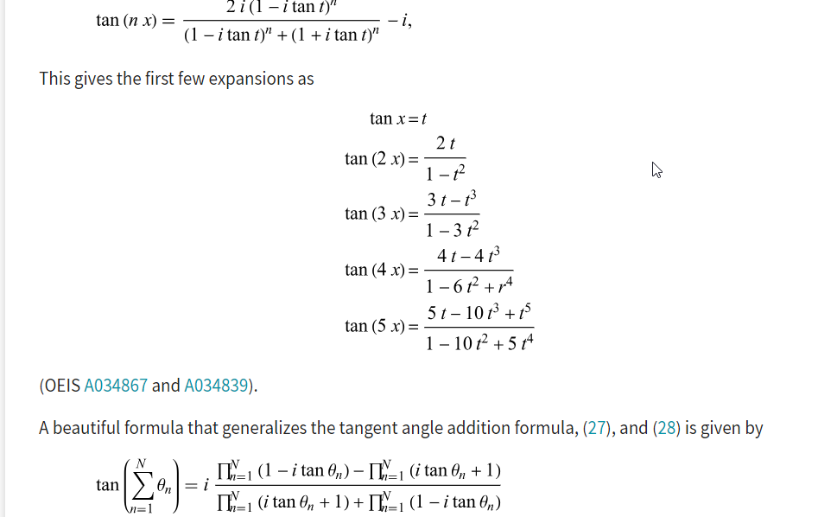

<https://www.physicsforums.com/threads/tan-6x-is-exactly-the-same-thing-as-6-tan-x.721677/>

